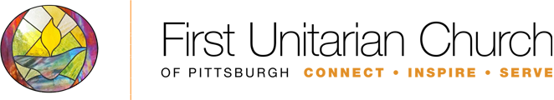
Our Whole Lives (OWL) Sexuality Education for Junior High
2017 – 18 Program
Honest, accurate information about sexuality changes lives. It dismantles stereotypes and assumptions, builds self-acceptance and self-esteem, fosters healthy relationships, improves decision making, and has the potential to save lives. For these reasons and more, we are proud to offer Our Whole Lives (OWL), a comprehensive, lifespan sexuality education curricula for use in both secular settings and faith communities. Interactive workshops and lessons engage participants. Six curricula speak to participants' needs, by age group. At First Unitarian Church of Pittsburgh, we offer the junior high (grades 7 – 8) every other year.
While Our Whole Lives is secular, it is not value-free. The program gives clear messages about the following key sexuality issues:
- self worth
- sexual health
- responsibility
- justice and inclusivity
Our Whole Lives recognizes and respects the diversity of participants with respect to biological sex, gender identity, gender expression, sexual orientation, and disability status. In every category of assessment, the curriculum meets or exceeds the National Standards for Sexuality Education Core Curriculum, K-12.
To preserve the quality of the experience, number of participants is+ limited and early registration is strongly recommended. In the event that a cut-off is necessary, priority consideration is given to families with longstanding involvement in the church. Prior parental permission and attendance at a mandatory orientation is required to attend the class.
To find out more, contact the Lifespan Religious Education Director, and/or attend this fall’s parent orientation on Wednesday, September 27th, 7-9pm downstairs in the Youth Group room. Child care will be made available upon request; RSVP required.

For questions, contact Erica Shadowsong, Lifespan Religious Education Director
412-621-8008 x103
eshadowsong@first-unitarian-pgh.org

