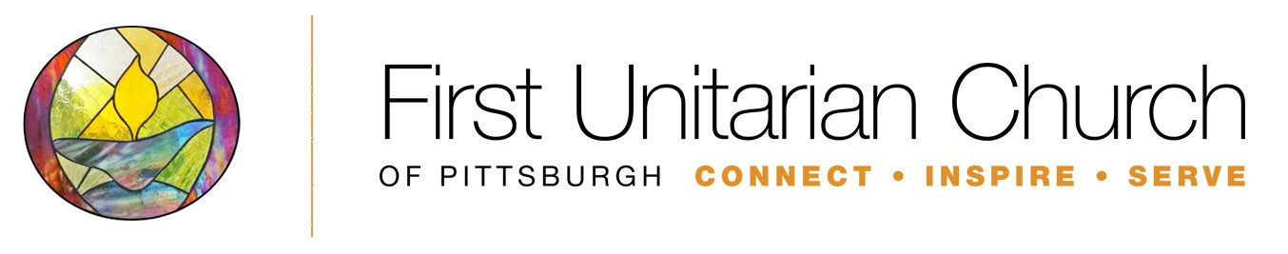

Parent/Guardian Consent Form
Our Whole Live: Sexuality Education for Grades 7-9

I/We give __________________________________________ [print child(ren’s) name(s)] permission to participate in Our Whole Live: Sexuality Education for Grades 7-9 at the First Unitarian Church Pittsburgh.

I/We have been offered the opportunity to view program materials. YES NO

I/We have attended an orientation to this program. YES NO
Print Name | Print Name
Signature Date | Signature Date

Please print information below:
___Father ___ Mother ___ Guardian ___ Other; please specify:
Name (Last) First

Address City State Zip Code

Telephone Alternate Telephone Best Contact Time E-Mail Address

___Father ___ Mother ___ Guardian ___ Other; please specify:
Name (Last) First

Address City State Zip Code

Telephone Alternate Telephone Best Contact Time E-Mail Address

