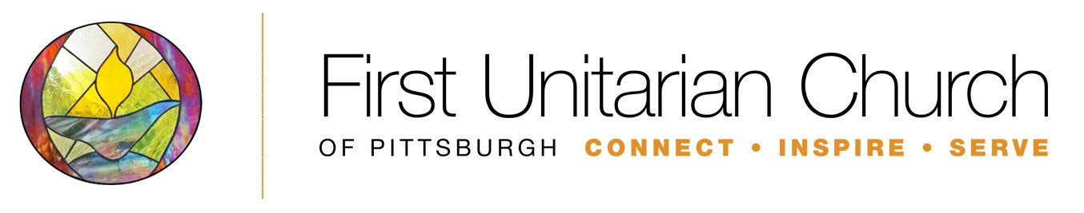

Religious Education (RE) Program—Parent’s Feedback Form
Use this form to give feedback and make suggestions about the Children’s Religious Education Program. The information you provide will go to the chairperson of the Religious Education Committee and to the Lifespan Religious Education Director (LRED) Thank you!

Your name (First and Last): Date:

In case we have questions about your feedback and need to contact you:

Phone Number:

E-mail Address:

Considering you or your child’s/children’s experience in the Religious Education Program:

- What do you think is going well? Please be as specific as possible.

- What could be improved? Please be as specific as possible.

Considering the RE Staff (the DRE, RE Committee, and Teachers):

- What do you think they are doing well? Please be as specific as possible.

- What could they improve? Please be as specific as possible.

Your involvement:

- Would you be interested in learning more about serving as an RE Volunteer?
Yes No

- Will you make a commitment to serve as a RE Teacher for one year (about 10-12 Sundays total) once in a two-year rotation?
Yes No

- Would you be interested in RE Committee work (one year commitment)?
Yes No

- Would you like someone to get back in touch with you after your comments have been reviewed? If so, how would you like to be contacted (e-mail, telephone, in person, other—please specify)?

